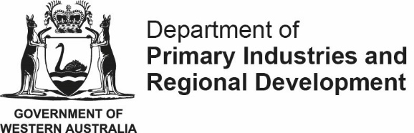
Regional Economic Development (RED) Grants – 2022 -23
The Goldfields-Esperance Development Commission (GEDC) received 27 RED Grant applications across the 2022-23 round. Applicants were seeking in excess of $4.1 million in funding to support projects to the total value of $10.4 million.
Recipient name | Project | Amount
Judumul Advisory Aboriginal Corporation | Judumul Cultural Hub: funding will assist in the purchase of equipment to enable Aboriginal artists to design and create their own wearable art products for sale at the Judumul Cultural Hub in Coolgardie. The project will provide employment and training opportunities to local and surrounding artists. | $113,000
Target Mining Resources Pty Ltd | Core Processing Training Centre: Development of a fit-for-purpose training and operating facility specialising in core processing and resource management. Trainees gain qualifications in safety, resource processing, or underground metalliferous mining, and receive industry-based experience. Funding will support the purchase of specialised core processing equipment and facility infrastructure to establish a new operating base for the business. | $140,000
Shire of Wiluna | Wiluna Caravan Park: Funding will support a new Caravan Park with the installation of an amenities block and camp kitchen to compliment the first stage of the project, which includes caravan parking bays, roads, and turning points. | $200,000
The Trustee for the Ned Baker Family Trust t/a Bread Local | Powering the Future of Bread Local: Funding will support the expansion of this niche Esperance bakery. The project includes the installation of ablution facilities for a restaurant/café, a new commercial oven, and power upgrades which will enable increased production, extended trading hours, and growth in wholesale supply. | $129,000

Kalgoorlie-Boulder  Viskovich House  377 Hannan Street  PO Box 751, Kalgoorlie WA 6430  P:08 9080 5000  F:08 9021 7941 | Esperance  Suite 26c Dutton Arcade  91 Dempster Street  PO Box 632, Esperance WA 6450  P: 08 9083 2222  F: 08 9071 3765
info@gedc.wa.gov.au
ABN: 38 440 402 612 / www.gedc.wa.gov.au

